SOMEHOW MY HEART STILL REMEMBERS YOU
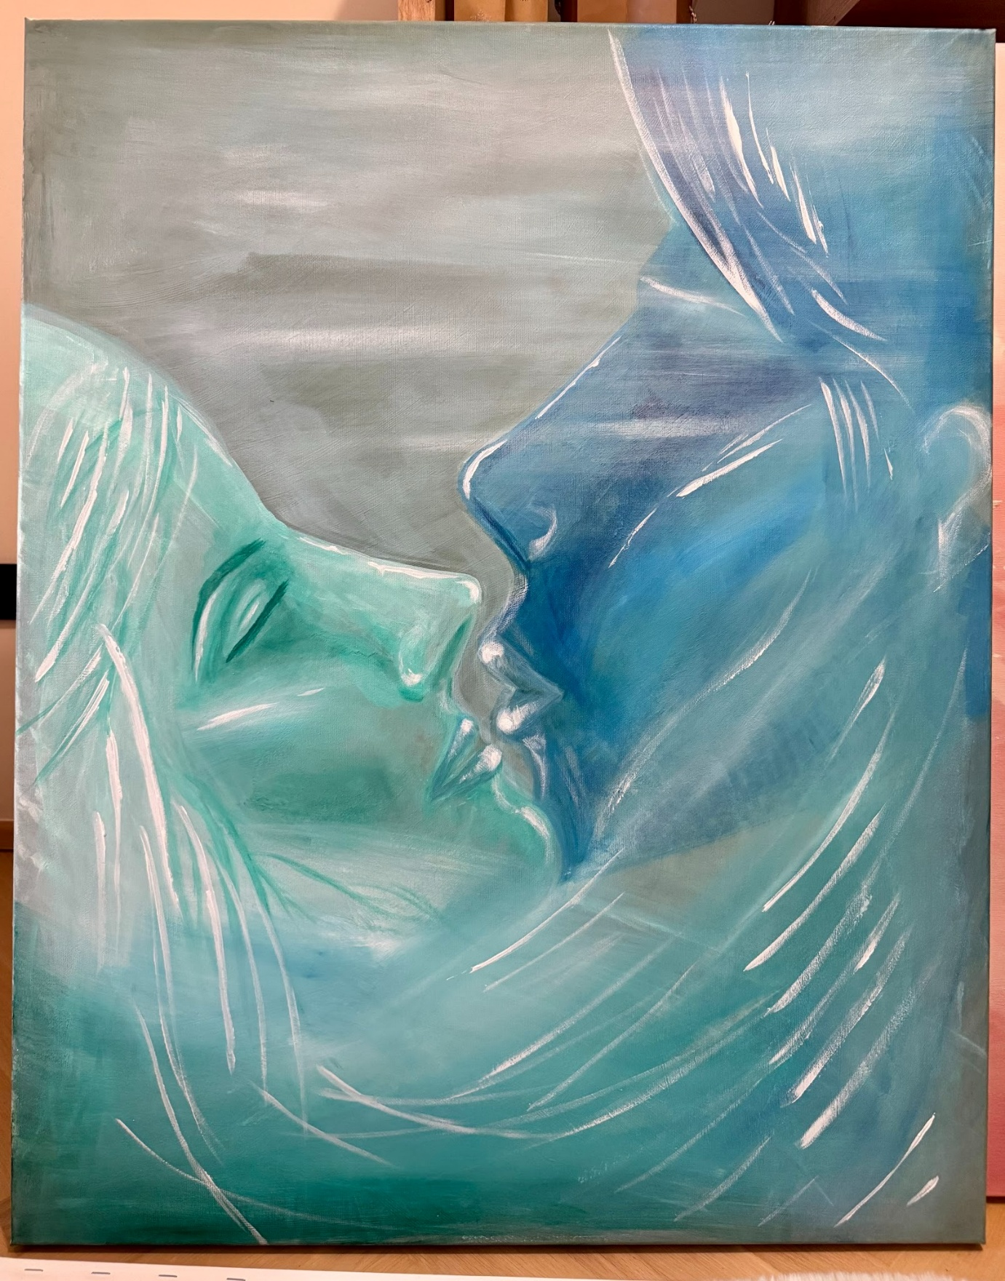

In another life, we loved beneath the stars,
two souls together, never truly apart.
Time may have changed the path we knew,
but somehow, my heart still remembers you.

Perhaps past lives leave traces behind—
a familiar soul, a love we cannot define.
And if we meet again when this life is through,
maybe I’ll remember
why I always found my way to you.

